COMP259 Lab 04 –Android Fragments
Complete each of the indicated demonstration apps and use them as a basis to complete Lab Assignment with the given requirements.

A) Readings and Exercises:
Android Programming Concepts by: Richard Cornez; Trish Cornez, 2015

1) Chapter 4 Fragments, ActionBar, and Menus
a) | Skim: | Skim the following sections before attempting the exercise:  4.1 Fragmentation and Android Fragments  4.2 The Fragment Lifecycle
b) | Exercises | Follow the steps in this section to produce and run the sample android application:  - Lab Example 4-3: Shades App: A Fragment Experiment  Completed Sample code is available on the handout drive:  \\dutch\pccommon\Comp259\Demonstrations\for Lab 04\Chapter04-Converted\Completed Applications\

B) Readings and Exercises:
Beginning Android 4 Application Development by: Wei-Meng Lee, 2012

1) Chapter 2: Activities, Fragments, and Intents
a) | Read: | Follow the steps in the section, “Fragments” to produce and run each sample android applications:  - Fragments > TRY IT OUT: Using Fragments  - Fragments > TRY IT OUT: Adding Fragments during Runtime  - Fragments > TRY IT OUT: Understanding the Life Cycle of a Fragment  - Fragments > TRY IT OUT: Communication between Fragments

C) Demonstrations:
Follow the in class Demonstrations for an overview of using Android Fragments.

COMP259 Lab 04 – Redesign Multiple Activity Apps to Use a Single Activity with Multiple Fragments
Create and demonstrate the following working application to the instructor for marking.

Part A) Shipping Cost Calculator II App
Modify the android app from Lab Example 2-3: Shipping Cost Calculator so that instead of two simple layouts for portrait vs. Landscape orientation, the upper/lower and left/right portions of the UI are managed by two separate fragments:
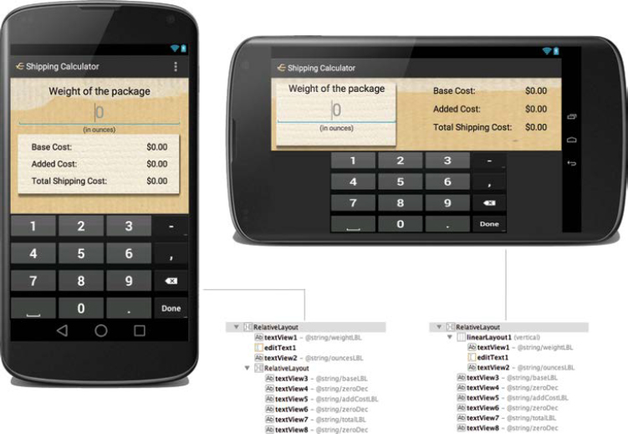

Part B) Automotive Calculator App
Modify the android app from Lab Example 3-3: Automotive Calculator so that instead of two activities that display the two “screens” in the UI, only one activity is used that switches between two fragments, one for each of the two “screens”. Leave out the code for the ActionBar, we will look this feature later.
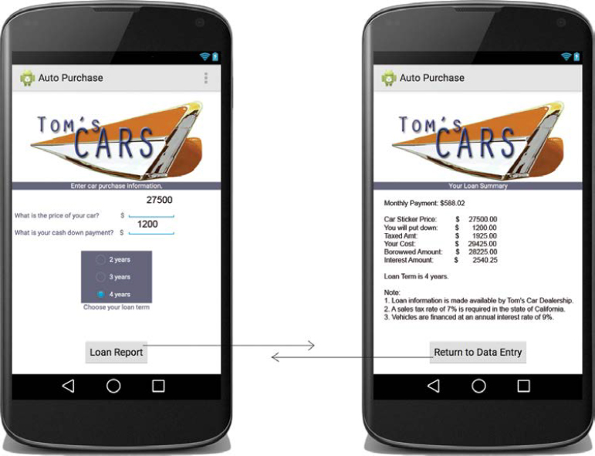
(end of lab 04)

